Chemistry Crossword Puzzle
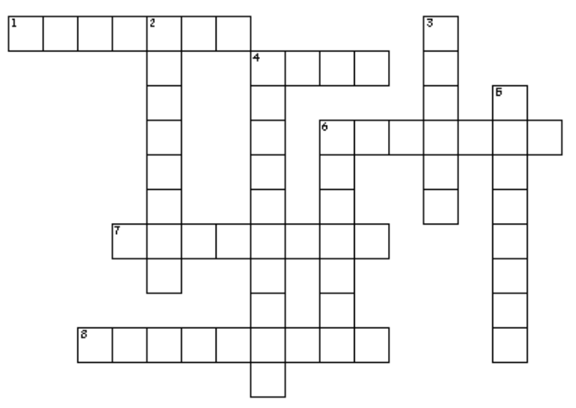

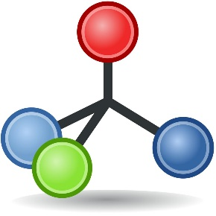

ACROSS  1. a substance made up of only 1 type of atom  4. the smallest unit of matter  6. a neutral particle found in an atom's nucleus  7. a group of atoms joined together into a new substance  8. a branch of science that deals with matter and how it behaves | DOWN  2. a very tiny, negatively charged particle found on the outside of an atom  3. a positively charged particle found in an atom's nucleus  4. a number that equals an atom’s protons plus its neutrons  5. a substance that is made up of 2 or more elements bonded together  6. the type of energy that is released when heavy atoms are split apart

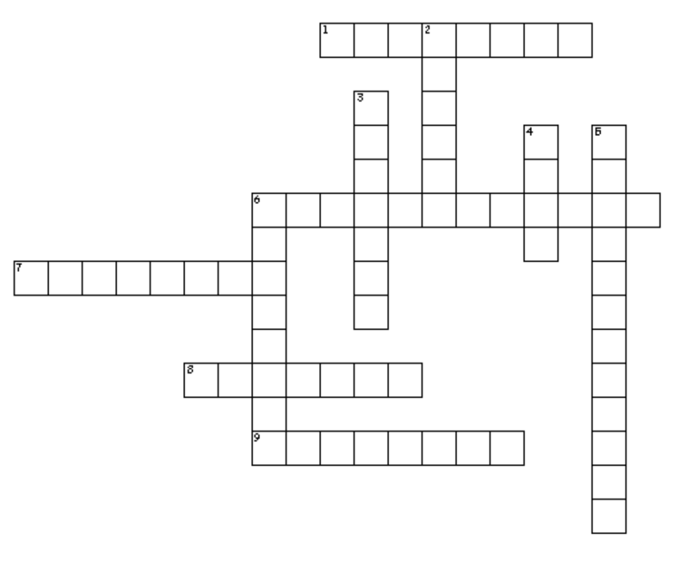
Chemistry Crossword Puzzle
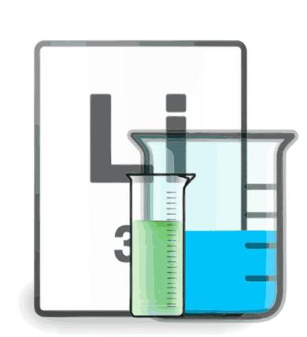

ACROSS  1. a substance that is made when the atoms of different elements bond together  6. the temperature at which a substance chance from a solid to a liquid  7. a type of change that results in new substances  8. a neutral particle found in an atom's nucleus  9. a negatively charged particle found in specific orbits around an atom's nucleus | DOWN  2. a positively charged particle found in an atom's nucleus  3. a variation of an element whose atoms contain a different number of neutrons compared to the common form  4. the smallest unit of an element  5. a physical change involving a gas changing into a liquid  6. a group of atoms bonded together to make a new substance not found on the periodic table

Word Bank: Puzzle #1 | Level: BASIC
Atom  Compound  Molecule  Electron  Proton | Neutron  Element  Chemistry  Atomic Mass  Nuclear

Word Bank: Puzzle #2 | Level: INTERMEDIATE
Atom  Compound  Molecule  Electron  Proton | Neutron  Isotope  Melting Point  Condensation  Chemical

