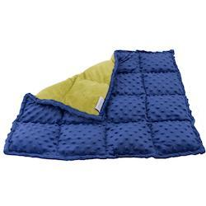
DEEP PRESSURE ACTIVITIES AND PRODUCTS
Weighted blankets, weighted lap pads, weighted vests, sensory compression pods, compression garments, and compression vests are portable examples of customizable deep touch pressure (DTP) products. Examples of deep touch pressure activities can include:
- Rolling/wrapping a child firmly in a blanket to make a “burrito”
- Squishing a child between two soft pillows (“sandwich”)
- Firmly rolling a therapy ball or RollEase Foam Rolling Pin on top of a student’s trunk, legs, and arms
- Deep vibration to whole body
- Wearing of weighted vests or compression garments
- Weighted blanket use
- Bear Hugs
- Deep massage
- Use a hand held massager
- Vibrating pen
- Joint Compressions
- Climbing under sofa cushions
- Deep Pressure seating options like the Sensory Pea Pod
- Heavy rub down with at towel
Explore a variety of tactile mediums to improve the child’s tolerance for touch, such as:
- Drawing in kinetic sand
- Foam soap or shaving cream play
- Rolling up in a sleeping bag. Add pillows on top to provide more deep pressure input
- Jumping on crash pads
- Playing in sensory bins with dry rice, beans, lentils, and other materials

